Cognizant Academy teams want to maintain a list of trainers along with their expertise in a SPA using React as the technology. You are assigned the task of creating this React app.

The following trainers’ data application will deal.

T-ID

Name

Phone

Email

Stream

Skills

Create a new React app using *create-react-app* tool with the as “TrainersApp”

Open the application using the VS Code

Add a new file called *trainer.js* inside the **src folder** and define a class named as “Trainer” with the following properties

TrainerId

Name

Email

Phone

Technology

Skills

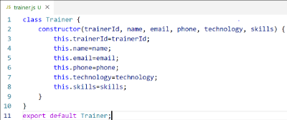

*Figure 2: Trainer.js*

Create a new TrainersMock.js file which will contain the mock trainer data. Refer the following screenshot for mock data

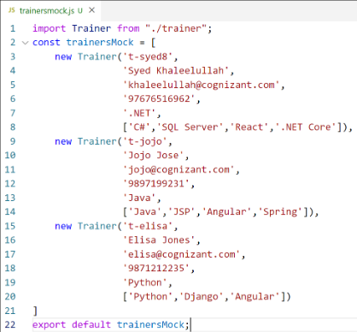

*Figure 3: TrainersMock.js*

Install the support for React router for the dom. Execute the following command.

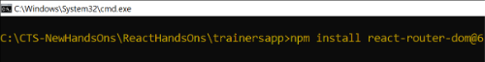

*Figure 4: Install React Router*

Create new component named as **TrainersList** inside *Trainerlist.js* file. The component should accept the trainer’s data as parameter and render it as a list. The list should display names of each trainers which must be clickable like a hyper link. Refer the following screenshot for the component layout.

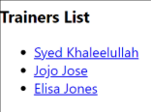

*Figure 5: TrainersList Component*

Create a new component named as Home inside Home.js which will be responsible for displaying the following



*Figure 6: Home Component*

Modify the App component to add support for routing and defining the navigation links to Home component and TrainersList component. Use BrowserRouter, Routes, Route and Link components from the react-router-dom library.

Define the following URL

/ - must redirect to home component

/trainers – must redirect to trainers list component.

The layout of the page must be similar to the following



*Figure 7: App Component*

Create a new component named **TrainerDetail** in *TrainerDetails.js* file.

The component should retrieve a parameter named id from the URL with the help of “useParams” hook from the React router DOM library.

It should query the mock trainer data using the id and display the trainer details as show in screenshot.

Modify the TrainersList component to add Links to TrainerDetail component while passing the ID. Define a route in App component for the same.

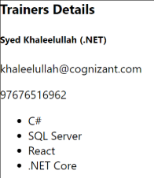

*Figure 8: Trainers Detail Component*

Build and run the application. The complete layout of the application will look as follows.

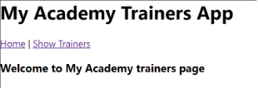

*Figure 9: Home*

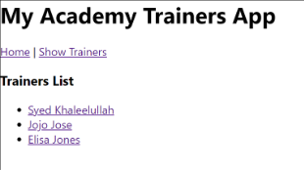

*Figure 10: Trainers List*

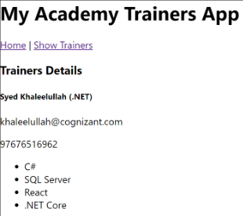

*Figure 11: Trainer Details*

**CODE:**

**File: Trainer.js**

class Trainer {

constructor(trainerId, name, email, phone, technology, skills) {

this.trainerId = trainerId;

this.name = name;

this.email = email;

this.phone = phone;

this.technology = technology;

this.skills = skills;

}

}

export default Trainer;

**File: TrainersMock.js**

import Trainer from './Trainer';

const trainers = [

new Trainer(1, "Alice Johnson", "[alice@example.com](mailto:alice@example.com)", "9876543210", "Full Stack", ["React", "Node.js", "MongoDB"]),

new Trainer(2, "Bob Smith", "[bob@example.com](mailto:bob@example.com)", "8765432109", "Frontend", ["HTML", "CSS", "JavaScript"]),

new Trainer(3, "Charlie Brown", "[charlie@example.com](mailto:charlie@example.com)", "7654321098", "Backend", ["Java", "Spring Boot", "Hibernate"]),

];

export default trainers;

**File: TrainerList.js**

import React from 'react';

import { Link } from 'react-router-dom';

function TrainersList({ trainers }) {

return (

<div>

<h2>Trainers List</h2>

<ul>

{trainers.map(trainer => (

<li key={trainer.trainerId}>

<Link to={`/trainer/${trainer.trainerId}`}>{trainer.name}</Link>

</li>

))}

</ul>

</div>

);

}

export default TrainersList;

**File: Home.js**

import React from 'react';

function Home() {

return (

<div>

<h1>Welcome to TrainersApp</h1>

<p>Use the menu to view the list of trainers or their details.</p>

</div>

);

}

export default Home;

**File: TrainerDetails.js**

// src/TrainerDetail.js

import React from 'react';

import { useParams } from 'react-router-dom';

import trainers from './TrainersMock';

function TrainerDetail() {

const { id } = useParams();

const trainer = trainers.find(t => t.trainerId === parseInt(id));

if (!trainer) return <p>Trainer not found!</p>;

return (

<div>

<h2>{trainer.name}</h2>

<p><strong>Email:</strong> {trainer.email}</p>

<p><strong>Phone:</strong> {trainer.phone}</p>

<p><strong>Technology:</strong> {trainer.technology}</p>

<p><strong>Skills:</strong> {trainer.skills.join(', ')}</p>

</div>

);

}

export default TrainerDetail;

**File: App.js**

import React from 'react';

import { BrowserRouter as Router, Routes, Route, Link } from 'react-router-dom';

import Home from './Home';

import TrainersList from './TrainerList';

import TrainerDetail from './TrainerDetail';

import trainers from './TrainersMock';

function App() {

return (

<Router>

<div>

<nav>

<Link to="/">Home</Link> |{" "}

<Link to="/trainers">Trainers List</Link>

</nav>

<Routes>

<Route path="/" element={<Home />} />

<Route path="/trainers" element={<TrainersList trainers={trainers} />} />

<Route path="/trainer/:id" element={<TrainerDetail />} />

</Routes>

</div>

</Router>

);

}

export default App;

**OUTPUT:**

